Reports & Dashboard Validation Document
Date | 30 September 2026
Team ID | SWTID-2026-7220
Project Name | Import Data using Transform Maps (Spreadsheet)
Maximum Marks | 4 Marks

Reports Created
Report | Purpose | Data Source | Screenshot
Employees by Department | Shows employee distribution by department. | Employee Test [u_employee_test] | Attach report screenshot
Employees by Location | Shows employee distribution by location. | Employee Test [u_employee_test] | Attach report screenshot
Employee List Report | Displays employee records in list format. | Employee Test [u_employee_test] | Attach report screenshot

Dashboard
Dashboard Name: Employee Analytics Dashboards
Purpose: Provide a centralized view of employee data using the project reports.
Current dashboard state: Dashboard created. Add the three reports/visualizations once the dashboard has writable access.

Screenshots to Attach
1. Employee Import staging table containing the 4 imported rows.
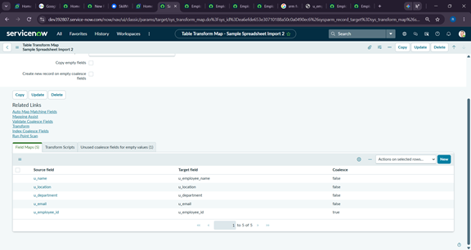
2. Sample Spreadsheet Import Transform Map.
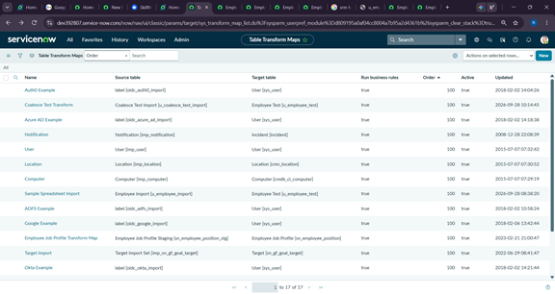
3. Employee ID field map with Coalesce enabled.
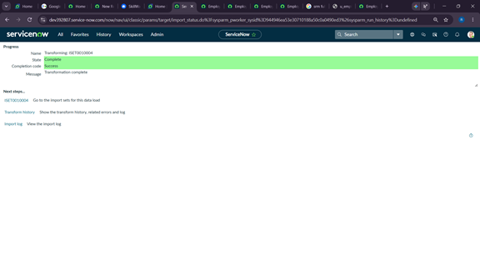
4. Transform History showing the first import results.
